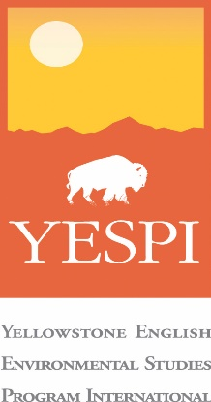
Yellowstone Summer Academy
July 8 to 19, 2018
An American University Accredited Program

Leadership, Environmental Studies, and Scientific Field Research in the Yellowstone

Day 1 – July 8, 2018 – Arrival Day
Students arrive to Yellowstone Bozeman International Airport (BZN).
AM: On the way to Montana
PM: Arrive at Bozeman. Shuttle to campus to rest and recover from jet lag. Shopping as time allows.
Evening: Enjoy a light dinner before bed.
Lodging: Montana State University (MSU) Campus Dormitory

Day 2 – July 9, 2018 – Research Methodology, ISP Topic Selection, and Research Plan - An American University Accredited Research Project.
AM: Breakfast on campus. Research methodology workshop for the Independent Study Project (ISP)
PM: Lunch on campus. ISP Topic Selection and Research Plan
Evening: Welcome Dinner with presentation on the Greater Yellowstone Ecosystem
Lodging: MSU Campus Dormitory

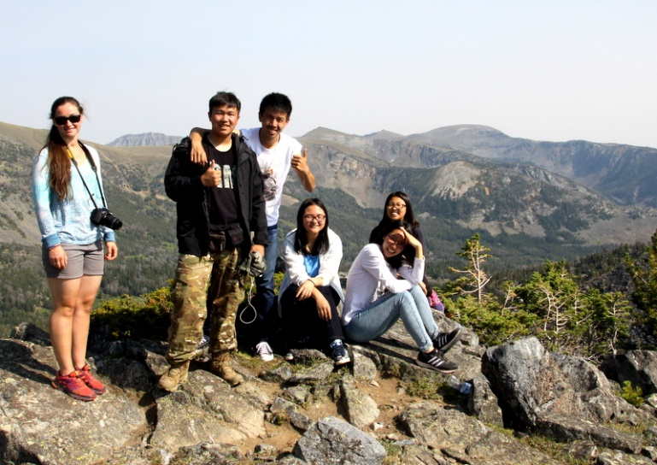

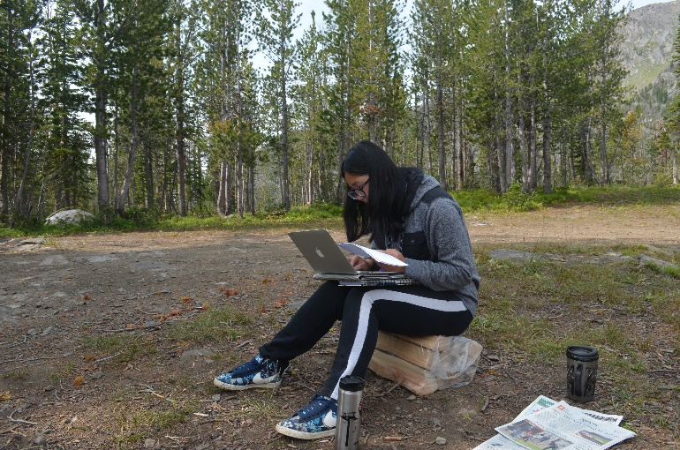

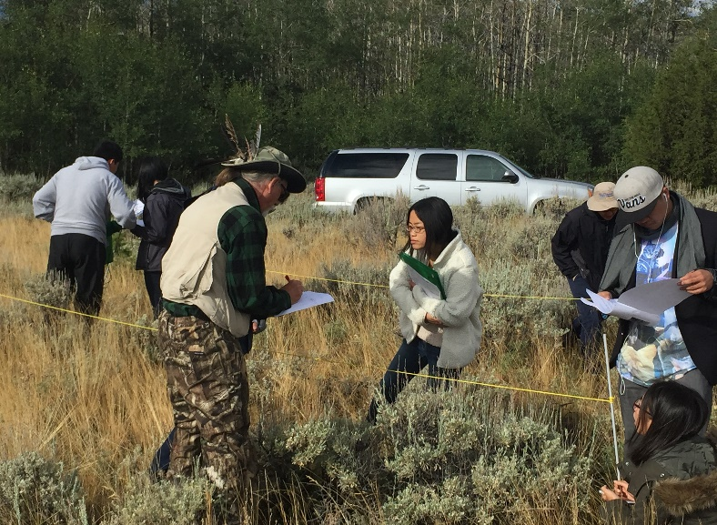

Day 3 – July 10, 2018 – Photography Workshop
AM: Breakfast on campus. Photography workshop for DSLR cameras and smart phones
PM: Lunch on campus. Photo editing and presentation. Finalizing ISP topics.
Evening: Dinner on campus. Photography plan for the ISP topic.
Lodging: MSU Campus Dormitory

Day 4 - July 11, 2018 – Full day tour of Yellowstone National Park with ISP photography shoots
AM: Breakfast on Campus. Full day tour of Yellowstone National Park with ISP photo shoots.
PM: Lunch on the road. Yellowstone National Park tour and ISP field interviews and photo shoots of the Lamar Valley and Grand Canyon of the Yellowstone
Evening: Return to West Yellowstone. Dinner at the WYED Center
Lodging: WYED Center

Day 5 - July 12, 2018 – Grizzly Wolf Discovery Center and ISP Field Research
AM: Breakfast at the WYED Center. Visit and tour of the Grizzly Wolf Discovery Center.
PM: Lunch at the WYED Center. ISP field work with YESPI staff.
Evening: Dinner at the WYED Center. Continued ISP field work including secondary research.
Lodging: WYED Center

Day 6 - July 13, 2018 – White Water Rafting
AM: Breakfast at WYED Center. Drive to Big Sky for whitewater rafting on the Gallatin River.
PM: Lunch on or near the Gallatin River. White water rafting. Tour and shopping in Big Sky.
Evening: Dinner at WYED Center. Free time after dinner.
Lodging: WYED Center

Day 7 – July 14, 2018 – Backcountry Camping and ISP Field Work
AM: Breakfast at the WYED Center. Drive to backcountry camp and set up camp for next two days.
PM: Lunch in camp. Day hikes in backcountry.
Evening: Dinner in camp. Free time to work on ISP.
Lodging: Back country camping

Day 8 – July 15, 2018 – Backcountry Camping and ISP Field Work
AM: Breakfast in camp. Wildlife ecology activities and hikes in the back country of the Yellowstone
PM: Lunch in camp. Climb Black Butte Mountain (10,547 feet elevation).
Evening: Dinner in camp. ISP field work and interviews with YESPI staff and sources.
Lodging: Back country camping

Day 9 – July 16, 2018 – ISP Interviews and Field Work in Yellowstone Park
AM: Breakfast at WYED Center. ISP Field Work in West Yellowstone.
PM: Sack lunch on the road. Second trip to Yellowstone Park to visit Old Faithful and other geysers
Evening: Dinner at WYED Center. ISP photo editing.
Lodging: WYED Center

Day 10 – July 17, 2018 – ISP Presentation Skills Workshop
AM: Breakfast at WYED Center. Drive to Bozeman. Presentation Skills Workshop.
PM: Lunch on MSU Campus. Finalize ISP Presentation.
Evening: Dinner on Campus.
Lodging: MSU Campus Dormitory

Day 11 – July 18, 2018 – ISP Presentation
AM: Breakfast on campus. ISP Presentations and Defense to full committee. This ISP has been accredited by Montana Tech. Students can earn two American University Credits from this program.
PM: Lunch on campus. Final shopping in Bozeman.
Evening: Farewell Dinner in Bozeman
Lodging: MSU Campus Dormitory

Day 12 – July 19, 2018 – Fly home
AM: Morning shuttle to Bozeman for flight home

End of YESPI Summer Program

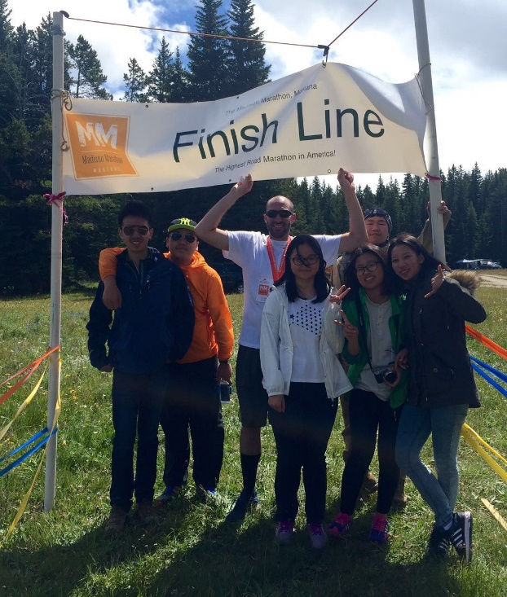

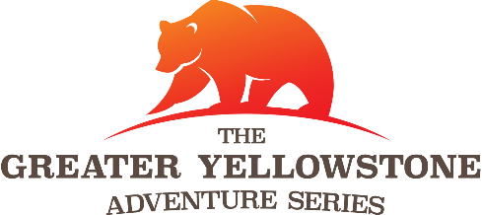

Marathon Internship Option

Day One – July 19, 2018
Drive to Ennis and set up marathon operations. Prepare SWAG, organize check in, set up course route, and several other duties for a double marathon weekend (Madison Marathon and Big Sky Marathon).
Day Two – July 20, 2018
Set up route of Madison Marathon and Big Sky Marathon. Check in for all runners. Host pre-race dinner. Finalize aid station materials for race weekend.
Day Three – July 21, 2018 – RACE DAY
Full day of volunteering for the 11th Annual Madison Marathon. Support runners, record time, and monitor results. Take down Madison aid stations and set up Big Sky Marathon aid stations.
Day Four – July 22, 2018 – RACE DAY
Full day of volunteering for the 4th Annual Big Sky Marathon. Support runners, keep time, and monitor results. Final take down and cleanup of both marathon routes.
Day Five – July 23, 2018
Return to Bozeman airport (BZN) for return home.

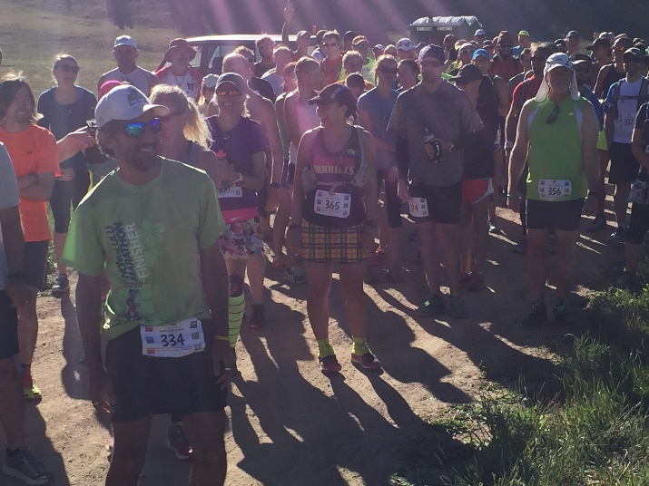

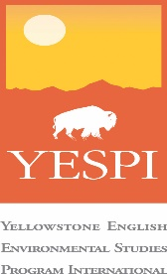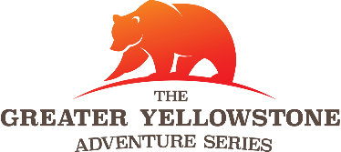

Frequently Asked Questions

How will you ensure the safety of the students?
Our number one priority is student safety. While the students are in the program, there will be a teacher/chaperone to student ratio of 1:4 (one chaperone or teacher for every four students). In addition, all students must purchase travel insurance before joining the program. YESPI is an American company and will also carry an American insurance policy. The 1:4 teacher/chaperone ratio will begin on Day One of the program and continue to the final day of the program including the marathon internship.

Can parents attend the program with their children?
Parents are encouraged to fly with their children as far as Bozeman Montana. At that time, YESPI will take over and the parents will be given a suggested itinerary of things to do in the Montana region while the students are in the program. The parents will be invited to attend certain programs such as the ISP Presentation of the students.

Who will be in the program?
YESPI is marketing its programs to high school students in China, Vietnam, and America. The goal is to have an inclusive, international, and unique mix of students for all its programs.

What is the minimum English ability required to take part in the program?
The students must have an ability to communicate in English. This program is NOT an ‘English learning camp.’ The students should be able to use English for all learning activities. Any student who is in an International School will qualify. We do not require a TOEFL score to take part.

What will the students do for the marathon internship?
The marathon internship involves working with the Greater Yellowstone Adventure Series (GYAS) races. This is a six-race series and July 21/22 is the double marathon weekend. The students will work as volunteers on ALL aspects of

hosting and successfully managing both marathons. The GYAS will provide a letter to each volunteer noting their community service efforts and the hours they worked.

What is YESPI responsible for on the program?
YESPI will take care of all the issues involved with the program from airport pick up on Day One to airport drop off on the final day. These responsibilities include:
- All lodging and transportation within the Yellowstone
- All meals for each day of the program with the exception of snacks
- All recreation fees as detailed in the agenda
- All tuition and education fees with the exception of the purchase of academic credit from Montana Tech
- A teacher/chaperone to student ratio of 1:4

What are the families responsible for on the program?
The families are responsible for the following:
- International airfare from their home to Bozeman Montana (BZN) and return
- Applying for and obtaining a US tourist visa to enter the United States. YESPI will write an invitation letter for the US Consulate.
- Purchase of travel insurance to cover all possible emergencies of the student while he or she is in the program
- Provide the student with enough personal spending money to purchase gifts, buy snacks, and other souvenirs.

How much are the program fees and how do families pay?
Please contact us directly for the price for the summer program. The price for the marathon internship is $500 per person.
YESPI is an American company so it will issue an American company invoice to all participants in the program. The program fees should be wired to the USA accounts of YESPI in US Dollars. Wiring instructions will be provided.
The tuition fees for the university academic credit is in addition to YESPI’s program fees. The credits will be issued by Montana Tech for the ISP and payment must be made directly to the university. Based upon 2017 tuition rates, the cost for two credits is $1,933.

How do we reserve a spot for our child?
To reserve a spot and guarantee entry into the program, families must pay a deposit of US$500 by April 30, 2018.

For more information on this summer camp program or to sign up and reserve a spot, contact the YESPI team today by phone, email, or WeChat. Also visit our website at www.yespi.net
The YESPI team is happy to speak with any schools, agencies, parents groups, or individual parents about the Yellowstone Program including providing a formal presentation at your school or institution.
Sam Korsmoe (English and Vietnamese language)
Tel: (86) 138-1814-7492
Email: sam@yespi.net
WeChat ID: Sam_Korsmoe

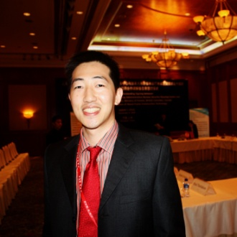
Francis Huang (English and Mandarin language)
Tel: (86) 139-0197-1151
Email: franciszhuang@gmail.com
WeChat ID: francishuang

Sally Liang (Shanghainese, Mandarin, and English language)
Tel: (86) 139-1796-2264
Email: 2282851001@qq.com
WeChat ID: scallion_liang

